OSGI

Introduction

OSGI - Open Services Gateway initiative
The OSGi specification describes a dynamic modular system and a service platform for the Java programming language that implements a complete and dynamic component model, something that does not exist in standalone JVM environments.
It is published by the OSGi Alliance, a consortium of leading software vendors, telecom companies and other organisations. It powers most popular IDE, web applications like eBay, Salesforce.com and Liferay, and is used by governments and militaries such as the U.S. Air Force and Federal Aviation Administration.
OSGi was made for IoT – from the start OSGi was designed for embedded devices, years ago when memory and CPU resources were significantly constrained.
OSGi also provides many specifications to enable essential features for building open IoT ecosystems. These features include device management, software provisioning, and device abstraction which generalises devices from their underlying communication protocols. Companies like AT&T, Bosch, NTT, Deutsche Telekom, General Electric, Hitachi, Schneider Electric all benefit from using OSGi to build IoT solutions today, and have done for many years. With OSGi and IoT there are already millions of devices connected today.

OSGI areas
Core: the OSGI Framework
- Execution Environment – provides defined context for applications
- modularity – provides class loading and package specifications
- services – provides a collaboration model
- lifecycle and dynamicity - provides defined context for applications
- security – security layer is embedded in all layers
Enterprise: services and component on top of the Core Framework
- addressing enterprise use-cases such as
  - service distribution
  - component model and IoC
  - configuration and management
  - JavaEE integration
  - …
The OSGi specification has several implementations, for example Eclipse Equinox, Knopflerfish OSGi or Apache Felix.
Eclipse Equinox is the reference implementation of the base OSGi specification. It is also the runtime environment on which Eclipse applications are based.

OSGi Execution Environment
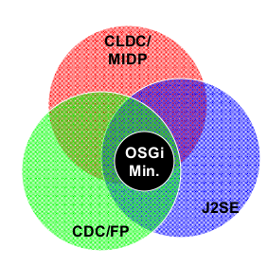

Define the class library available from the VM
- java.* classes
- Additional constraints

OSGi APIs use only a subset of Oracle’s J2SE and J2ME CDC/CLDC

Modularity ( in Java )
As we said, OSGI is dynamic modular system and is considered to have steep learning curve.
Is OSGI hard to learn or is modularity hard ?
Modularity in Java is something being talked about for quite a long time. We all use build systems like Maven, Gradle, Ivy... The build systems are brilliant, they automate and extremely simplify the build process, hiding immense deal of complexity e.g artifact versioning, transitive dependencies handling...
But modularity is a hard problem present for a long time, there we several attempts:
- JSR 8: Open Service Gateway Initiative - came out in March 1999
- JSR 277: Java Module System – JSR came out in 2005
- JSR 291: Dynamic Component Support for Java SE – another way of doing modules
- JSR 294: Improved Modularity Support in the Java
- JSR 376: Java platform module system – the most recently from 2014 JPMS estimated in March 2017.
18 years....
Modularity is hard, and not the OSGI...
But let's be fair and say that although OSGI specification is great it got stuck on either at the implementation layer or at the usability layer. Unwanted complexity was introduced on the development process. Things got better with Tycho and ( when using POM first approach ) enRoute project. But now I getting of the topic.
Modules in modular programming enforce logical boundaries between components and improve maintainability. They are incorporated through interfaces. They are designed in such a way as to minimize dependencies between different modules. Teams can develop modules separately and do not require knowledge of all modules in the system.
Modules are:
- self-contained – from the outside, a module must appear as logical whole.
- highly cohesive – a module should have just one, well-defined purpose, and achieve it.
- loosely coupled – a module should be ignorant of the implementation details of the dependent module. It should only be aware of its public interface
The benefits of using modular programming include:
- Separation of concerns – designing modules so that each module addresses a separate concern.
- Code reuse - Less code has to be written. A single procedure can be developed for reuse, eliminating the need to retype the code many times. The same code can be used in many applications.
- Design simplicity - Code is short, simple and easy to understand. Programs can be designed more easily because a small team deals with only a small part of the entire code.
- Parallel development - Modular programming allows many programmers to collaborate on the same application.
- Ease of maintenance and repair - Errors can easily be identified, as they are localized to a subroutine or function.

Is Java modular....
We have classes, packages, jars and build system that download dependencies and assembles lot and lots of jar. People think they have a modular system in Java, but it is not right.
Consider isolation:
- Fields are private
  - what about reflection
- fields are final
  - hmmm, we can use setAccessible
Modularity:
- classes are encapsulated
  - except we still have a lot of internal dependencies whether they are implementation dependencies or in signature like argument types.
  - They cannot be modules.
- packages
  - are boundaries for classes -
    - except cyclic references between packages can easily occur
    - they do not really matter for JVM. It introduced to provide unique signature for classes
- JARs are unique element of deployment, but NOT modules
  - JARs do not exists in runtime: when searching for a class JVM perfoms a linear scan of the CLASSPATH, starting from the left-most item.
“first one wins”
This is inefficient and unreliable process
  - JARs, by default, have no explicit declaration about dependencies. (except file based, Class-Path declaration)
  - no versioning -
Build system manage dependencies and versioning
- such versioning is static, a contract respected by the tools only. JVM keeps working with its linear CLASSPATH
- dependencies are easy to manage:
Think about a large Maven project, for example. Often you will come across dependency chains where multiple versions of the same dependency are built into the same application – your system then will choose the dependency that is listed first and load that one (typically alphabetically.) This can cause behavior that is different between development and production, if the ordering changes at all between the two environments.
Take a look at Jitwatch project
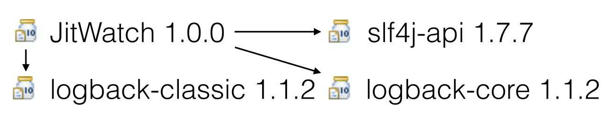
No lets take into consideration its transitive dependencies.
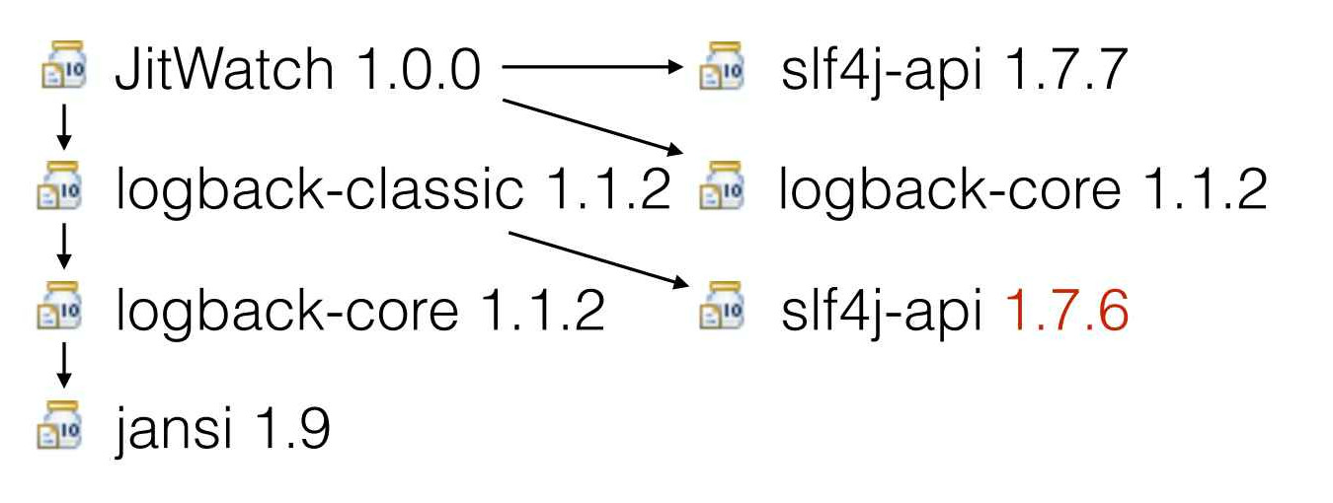
Things gets even complicated if we factor in optional dependencies. But we won't go there.

JVM - Class loading
The JVM loads class by class loaders (java.lang.ClassLoader). Responsibilities of a class loader:
- Finds a bytes of class – which could reside anywhere
- turn them into class
We can only override step 1. Step 2. is performed by native final method called defineClass() - so we are unable to change it.
Class loaders are organized in a hierarchical structure:
- each class loader has a parent,
- except the native class loader, which is the root of the tree
A class loader first asks its parent to load a class – and tries to locate such class only if the parent fails (parent-first delegation)
This is due to security reasons – the loading of core Java classes is enforced to be carried out by the native class loader, and not by a possibly malicious one.
Class loaders are crucial for the success of Java. They enabled moving Java into enterprise with Servlets. Now they allowed evolution of files JARs → Jmods
Module busting Class.forName() goes thru modules boundaries. Is OSGI, causes lot of problems when application depends on library that utilizes Class.forName() a lot e.g. Hibernate....
Class loaders are coming for you, whether it is OSGI or Jigsaw. So, watch out...
OSGI in essence is not so hard, modularity is.

How does OSGI enforce modularity....
Isolation is the most fundamental feature of any module system. There must be some means of protecting each module from interference by other modules running in the same application.
In OSGi, we used the package as the interface for modules. A bundle could therefore export (provide) a package and a bundle could import (require) a package. If a bundle imported a package then another bundle should export that package.
OSGi implements its isolation using class loaders. Each module – or “bundle” in OSGi terms – has a class loader that knows how to load the types within the bundle. It can also delegate class loading requests to the loaders of other bundles that it depends on. This system is highly optimised, for example OSGi does not create a class loader for a bundle until the last possible moment, and the fact that each loader sees a much smaller set of types means that each type can be loaded marginally faster.
The big advantage of this system is that bundles can contain overlapping packages and types, and these do not interfere. As a practical consequence, it's possible to have multiple versions of certain packages and libraries running at the same time in the same JVM. This is a boon when dealing with complex transitive dependency graphs that often result from using build tools like Maven.
The isolation barrier in OSGi is visibility. In OSGi we cannot load internal classes of a module because they are not visible from the outside. That is, my module's class loader can only see the types inside my module, plus the types explicitly imported from other modules. If I try to load an internal class from your module, my class loader cannot see that type. It is as if the type did not exist at all. If we try to go ahead and load the class anyway then we get a NoClassDefFoundError or ClassNotFoundException.
Due to OSGi's ClassLoader-based design, modules can obtain visibility of the non-exported packages and types of other modules... so long as they know the fully-qualified name of the type and which module to ask (remembering that several modules could contain any given type name). This is a pragmatic reduction of isolation in the spirit of Java's long-standing use of reflection, where even so-called private fields can be opened up by calling the setAccessiblemethod.

OSGI Metadata
Technically OSGi plug-ins are .jar files with additional meta information. This meta information is stored in the META-INF/MANIFEST.MF file. This file is called the manifest file and is part of the standard Java specification and OSGi adds additional metadata to it. According to the Java specification, any Java runtime must ignore unknown metadata. Therefore, plug-ins can be used without restrictions in other Java environments.
Bundle metadata:
- Symbolic name (required)
- Version (optional, but advised)
- Description
- List of imported and exported packages
- …
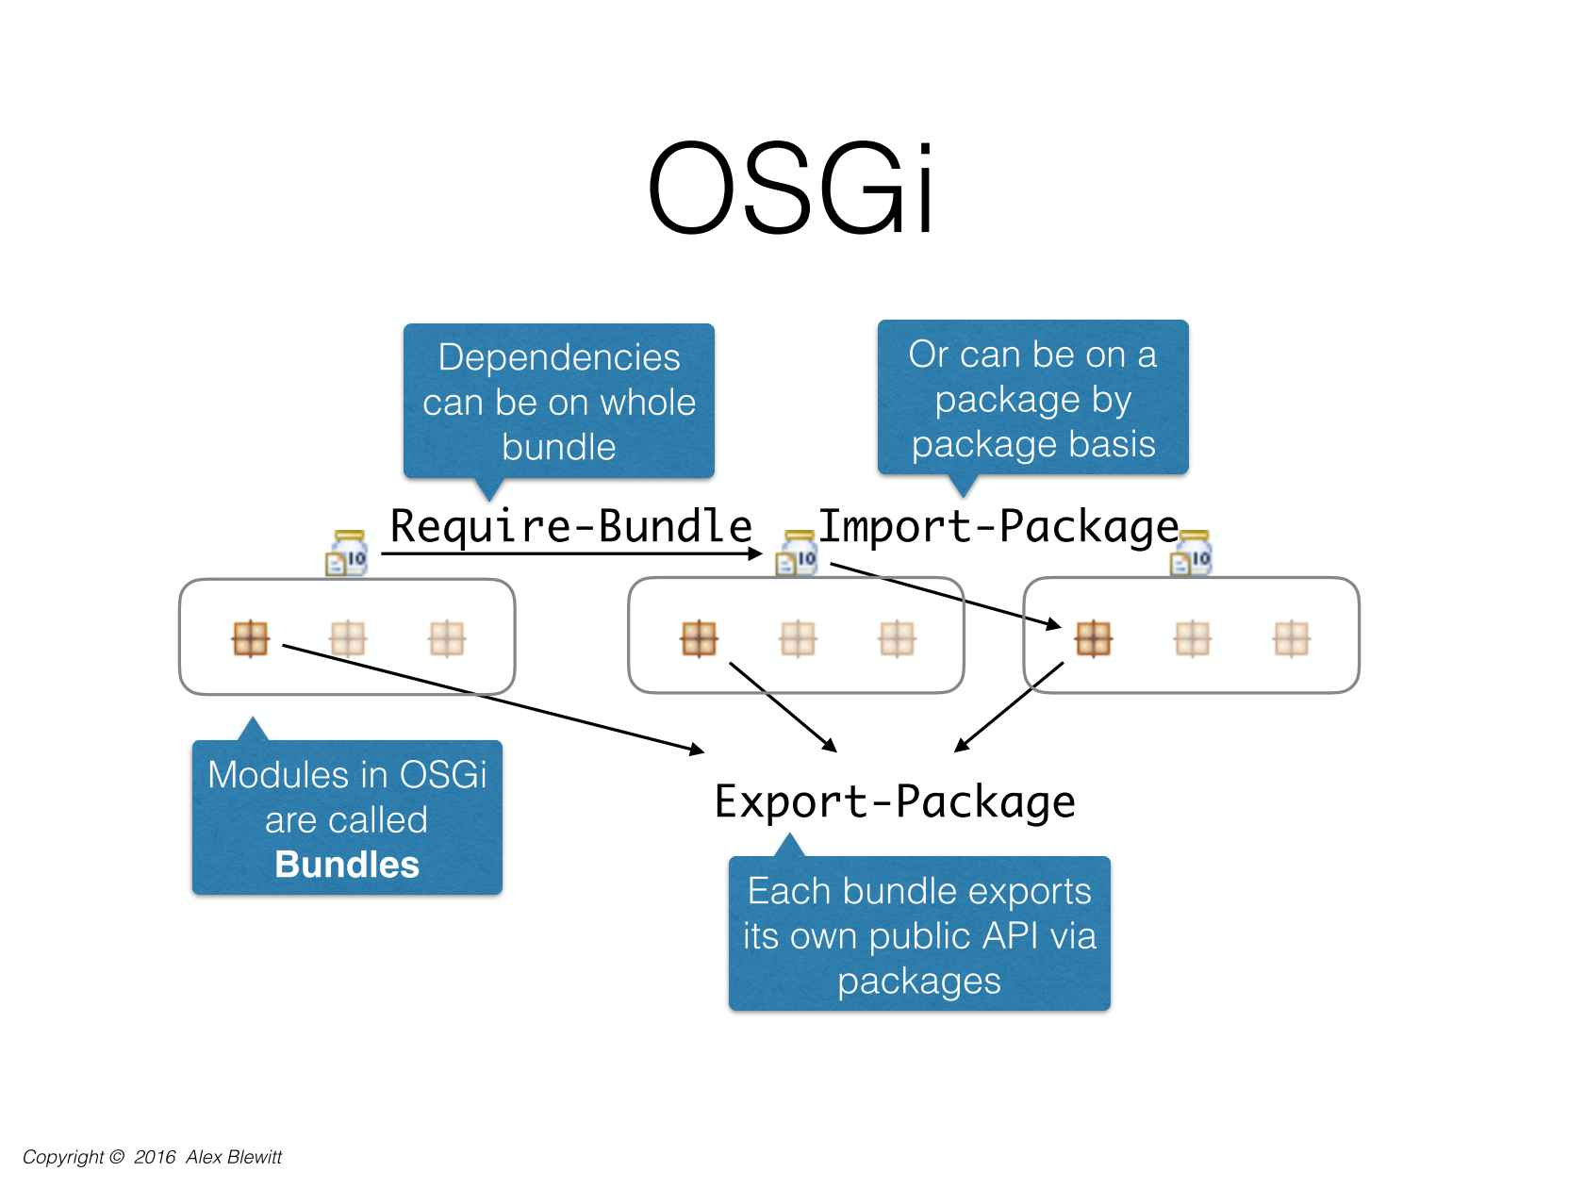
The OSGi Specifications supports both Require-Bundle and Import-Package
- Require-Bundle creates a dependency on a complete bundle
  - Simple to use
  - Imports packages that are never used
- Import-Package creates a dependency on just a package
  - Creates less brittle bundles because of substitutability
  - More cumbersome to use (Tools!)
  - The bnd utility takes the pain out of this
In almost all cases, Import-Package is recommended because it eases deployment and version migration.
The following listing is an example for a manifest file.
Manifest-Version: 1.0
Bundle-ManifestVersion: 2
Bundle-SymbolicName: com.example.myosgi
Bundle-Name: My OSGI bundle
Bundle-Version: 1.0.0
Import-Package: com.example.util
Require-Bundle: org.eclipse.osgi
Export-Package: com.example.myosgi
Bundle-Activator: com.example.myosgi.Activator
Bundle-ActivationPolicy: lazy
Bundle-RequiredExecutionEnvironment: JavaSE-1.6

Manifest file can be used for:
- construction of paths by the compiler
- for ensuring dependencies in runtime
- wiring projects in IDEs
- resolving dependencies from repositories
- showing content on GUI
- documentation – readable by humans

Semantic Versioning with OSGi

Bundles are versioned, just like Gradle or Maven artifacts...
OSGi recommends to use a <major>.<minor>.<patch> schema for the version number. If you change your bundle code you increase the version according to the following rule set.
- <patch> is increased if all changes are backwards compatible.
- <minor> is increased if public API has changed but all changes are backwards compatible.
- <major> is increased if changes are not backwards compatible.
Aside from bundle version, package can be versioned as well.

Export-Package: com.example.myosgi;version=”1.0.0”

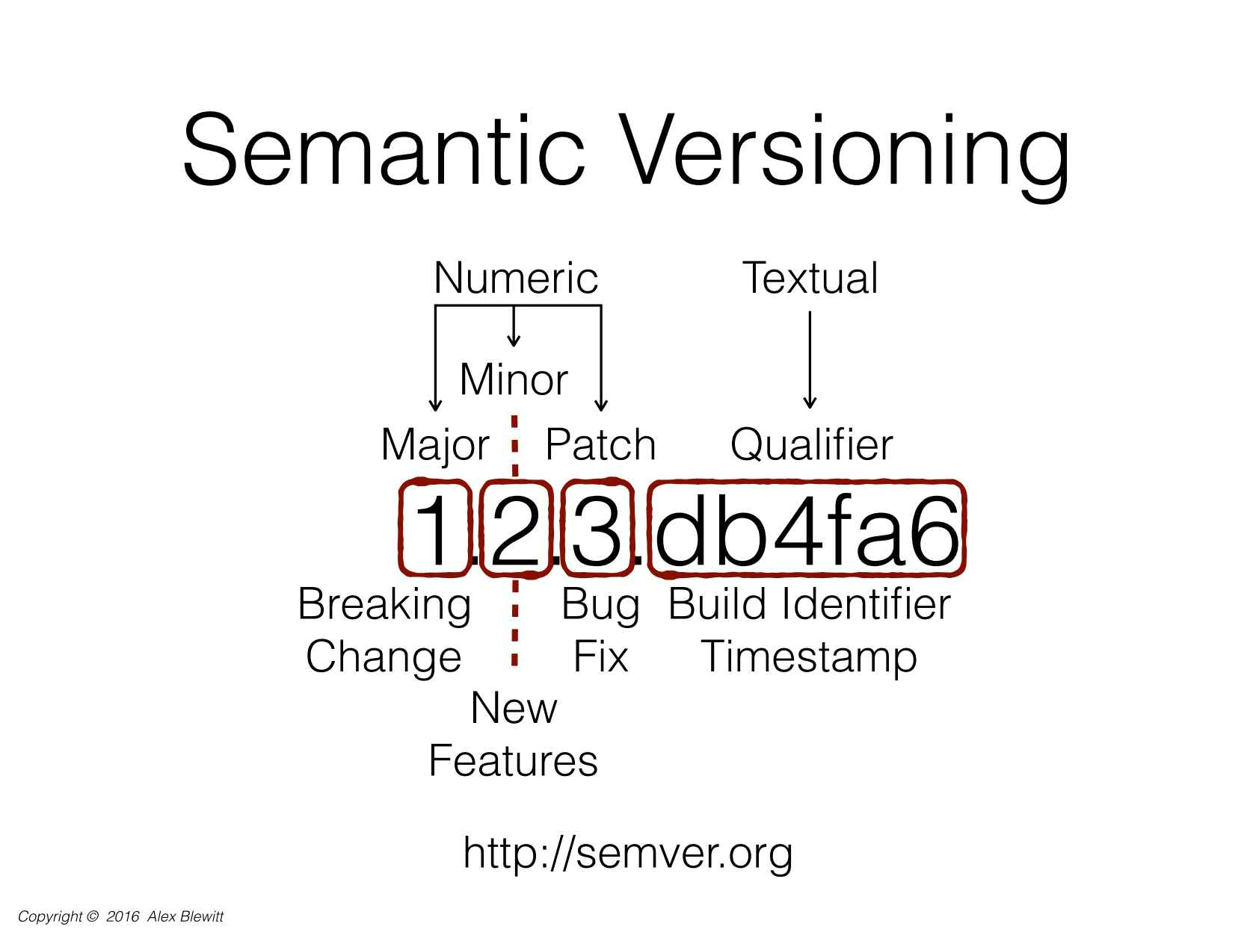
Without compliance to some sort of formal specification, version numbers are essentially useless for dependency management. By giving a name and clear definition to the above ideas, it becomes easy to communicate your intentions to the users of your software. Once these intentions are clear, flexible (but not too flexible) dependency specifications can finally be made.
There rules are defined in http://semver.org/

Services

The OSGi Service Platform provides a collaboration model that is
- service objects
- package sharing
A service is an object registered with the Framework by a bundle to be used by other bundles. A service in OSGi is defined by a standard Java class or an interface. The first step to define an OSGi service is to define the class or interface for which you want to provide a service. This is called the service interface.
As a second step you write the implementation class for the service interface.
You can register services implementations and consume existing services via the OSGi runtime. OSGi provides a central service registry for this purpose.

A dynamic registry allows a bundle to find and track service objects. Framework fully manages this collaboration
- Dependencies, security
- A service can be discovered dynamically
  - Active search with query filter
  - Listener interface
- Services can go away at any time! This is very dynamic!
- During the declaration of a service it is possible to specify key / values which can be used to configure the service
- It is possible to define a service ranking for a service via a service property. OSGi assigns by default a value of zero as the service ranking. The higher the ranking the better. Frameworks like the Eclipse dependency injection framework automatically inject the service with the highest service ranking.
Service Oriented Systems (SOS) have been the cornerstone of OSGi since its creation in 1998. At first, OSGI services were just called services, but they change the name after to micro-services after the SOA “stole the term” service.
What is the difference between OSGI Service Platform and SOA ?
OSGi Platform is a Service Oriented Architecture without communication overhead.
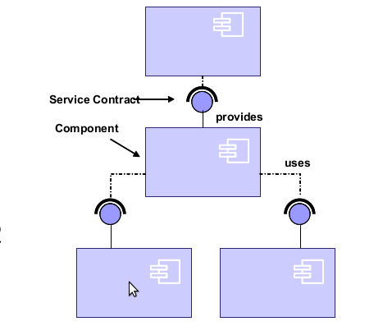
- Separate the contract from the implementation
- Allows alternate implementations
- Dynamically discover and bind available implementations
- Binding based on contract (interface definitions)
- Components are reusable
- Components are not coupled to implementation details of other components, only their independent interfaces have to be known

Recently, they changed the name again to μservice since micro-services are becoming used for the much heavier model of REST services.

How is OSGi related to Micro-Services?
What is OSGi’s focus? Modularity, class loading control, and small services that have a very focused purpose or even just a single purpose. That sounds a lot like micro-services.
The main difference is that micro-services are expected to each run in their own containers allowing for more control over development and updates, whereas an OSGi container might be host to multiple services.

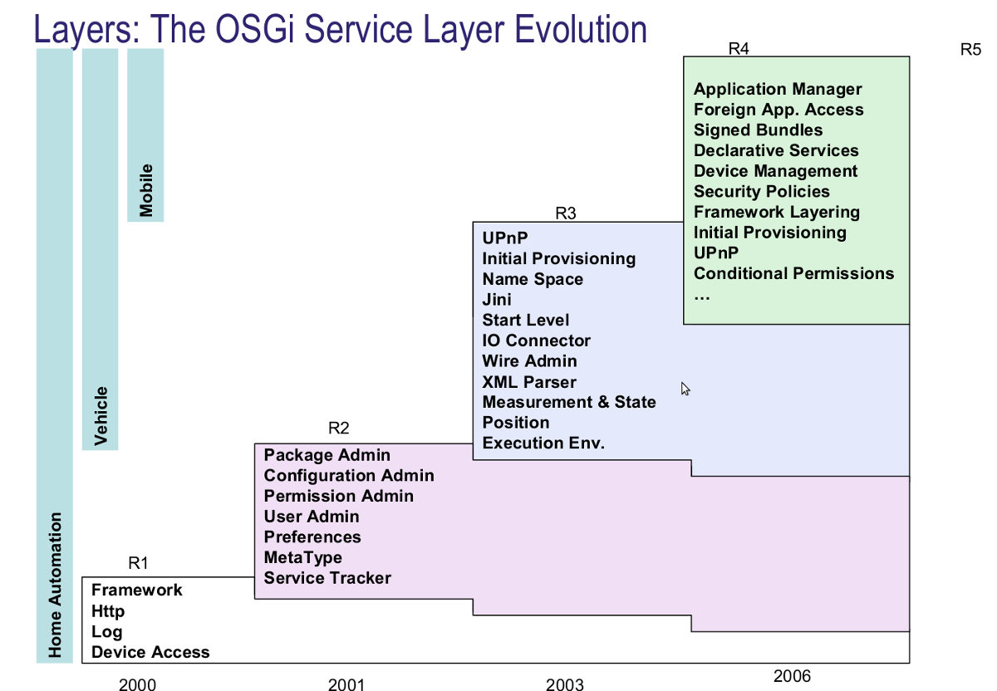

Life cycle of plug-ins in OSGi

The OSGI Framework:
- Reads the bundle’s manifest
- Installs the code and resources
- Resolves dependencies
- Controls the bundle life cycle
During Runtime:
- Calls the Bundle Activator to start the bundle
- Manages java class path for the bundle as a network of class loaders
- Handles the service dependencies
- Calls the Bundle Activator to stop the bundle
- Cleans up after the bundle
A Life Cycle layer adds bundles that can be dynamically installed, started, stopped, updated and uninstalled. Bundles rely on the module layer for class loading but add an API to manage the modules in run time. The life cycle layer introduces dynamics that are normally not part of an application. Extensive dependency mechanisms are used to assure the correct operation of the environment. Life cycle operations are fully protected with the security architecture.
Bundle State | Description
INSTALLED | The bundle has been successfully installed.
RESOLVED | All Java classes that the bundle needs are available. This state indicates that the bundle is either ready to be started or has stopped.
STARTING | The bundle is being started, the BundleActivator.start method has been called but the start method has not yet returned. When the bundle has an activation policy, the bundle will remain in the STARTING state until the bundle is activated according to its activation policy.
ACTIVE | The bundle has been successfully activated and is running; its Bundle Activator start method has been called and returned.
STOPPING | The bundle is being stopped. The BundleActivator.stop method has been called but the stop method has not yet returned.
UNINSTALLED | The bundle has been uninstalled. It cannot move into another state.

With the installation of a bundle in the OSGi runtime the bundle is persisted in a local bundle cache. The OSGi runtime then tries to resolve its dependencies.
If all required dependencies are resolved, the plug-in is in the
RESOLVED status otherwise it stays in the INSTALLED status.
In case several plug-ins exist which can satisfy the dependency, the plug-in with the highest valid version is used.
If the versions are the same, the plug-in with the lowest unique identifier (ID) is used. Every plug-in gets this ID assigned by the framework during the installation.
When the plug-in starts, its status is STARTING. After a successful start, it becomes ACTIVE.
This life cycle is depicted in the following graphic.
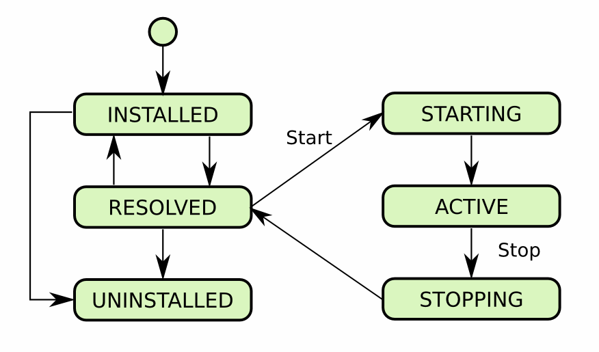

Further reading:
- http://www.vogella.com/tutorials/OSGi/article.html
- http://www.vogella.com/tutorials/OSGiServices/article.html
- http://blog.vogella.com/2016/06/21/getting-started-with-osgi-declarative-services/
- http://enroute.osgi.org/book/100-introduction.html
- https://www.infoq.com/articles/java9-osgi-future-modularity

